**C:\Users\Tshepo Legodi\Pictures\LOGOS\hurisa.tif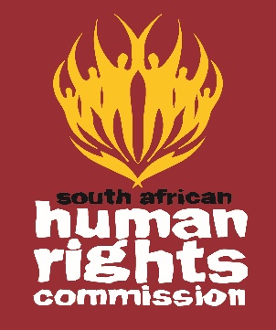**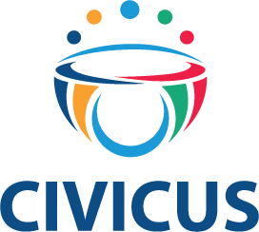[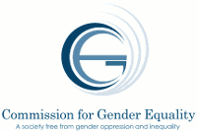](http://cge.org.za/)

|  |
| --- |
| **AFRICAN DAY OF HUMAN RIGHTS**  **PROGRAMME**  **Date: 20, October 2017**  **Hosted by the South African Human Rights Commission** |

09:15-09:30 Arrival & Registration

09:30- 09:45 **Opening, Introduction And Objectives**

09:45-10:15 **Opening Remarks :**

* Commission for Gender Equality,
* South African Human Rights Commission,
* Human Rights Institute of South Africa,
* CIVICUS

10:15-10:45 **Keynote Address**

* **Honourable Pansy Tlakula** - Chairperson of African Commission on Human and People’s Rights

10:45-11:00 Q&A

11:00-11:30 **Freedom of Association, Assembly & Expression**

* Teldah Mawarire: CIVICUS
* Zimkhitha Mvandaba: Huffington Post
* SAHRC

11:30-11:45 Q&A

11:45 – 12:00 Tea/ Coffee Break

12:00-12:45 **Protection of vulnerable groups**

* Sarah Motha Foundation for Human Rights,
* Lindiwe Khoza South Africa Women’s in Dialogue,
* Mawethu Nkolomba Human Rights Institute of South Africa,
* Brian Muziringa Disabled Migrant Rights Networking Organisation,
* Pulane Mafatshe Black Womxn Caucus;
* Lieketseng Mohlakoana-Motopi CGE

12: 45-13:00 Q&A

13:00-13:15 **Summary & Closure**